ALL DAX Function

**ALL function ignores the Filter(s)!!!**

In addition to returning a table as the output, ALL will also ignore any filter(s) applied on it. What does that mean? It means if you have a visualization which is filtered by something, **then ALL won’t care! It will just act like there is no filter there.**

Import Sales_data file.

**Create a New Measure:**

Grand Total = SumX(**All**(Sales),Sales[Cost])

Example 2: Based on AdventureWorks database

Create 2 measures in the FactInternetSales table.

First measure’s name is RelativeSumAmount

RelativeSum of Amount = SumX(**FactInternetSales**,FactInternetSales[SalesAmount])

In the above measure directly the table name is mentioned inside the SumX function. So it will be always getting changed as per the visual and /or as per the filter.

Second measure’name is GrandSumAmount

GrandSum of Amount = SumX(**All**(FactInternetSales),FactInternetSales[SalesAmount])

All function will show the sum of amount irrespective of any visual or filter!!!. It will just acts as a grand total!

In the Reports place a Matrix.

Place EnglishEducation from DimCustomer in Rows.

Then place both the measures in values section.

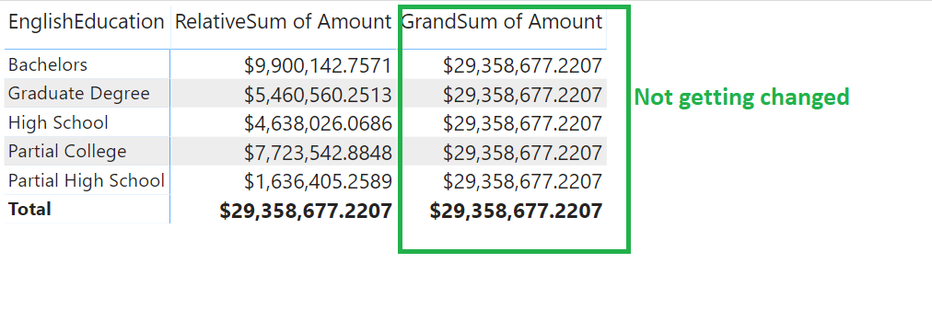

Now place a Slicer below this matrix. Put SalesTerritoryCountry from DimSalesTerritory table in it as shown next 🡪

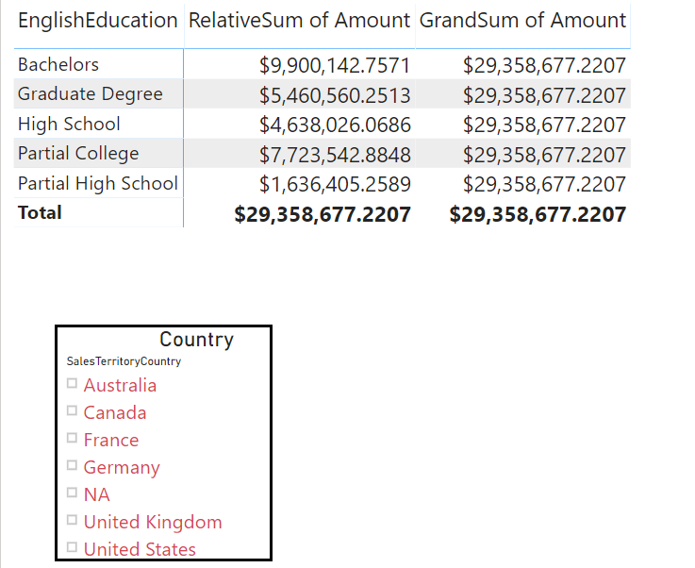

Now select Australia country from that slicer.

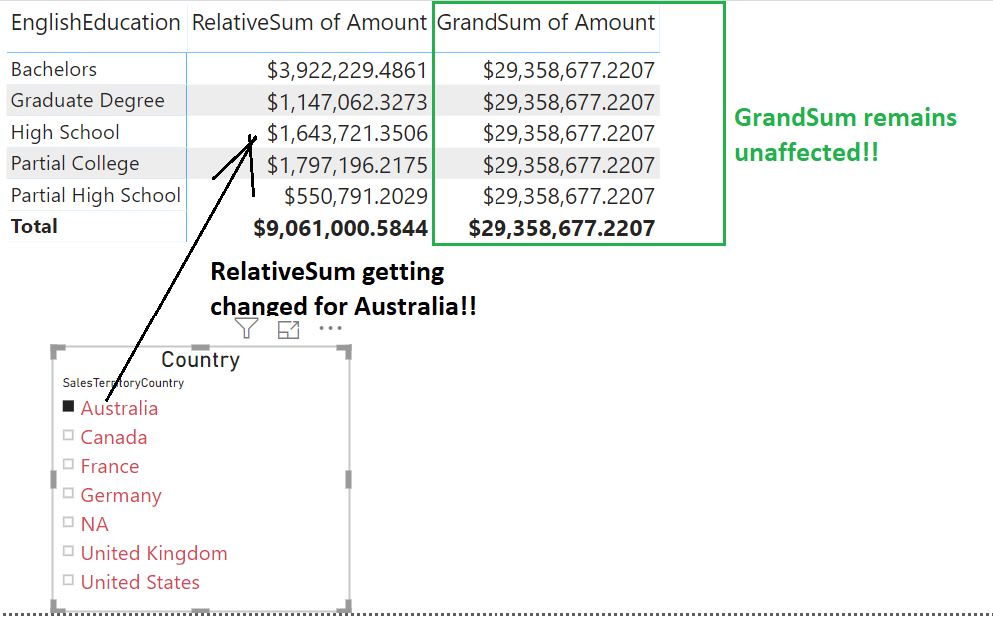

Generally, the measures created using All function are quite handy to display them **inside a card**. That will be **a static value** not getting changed due to any visual or filter of the page / report!!

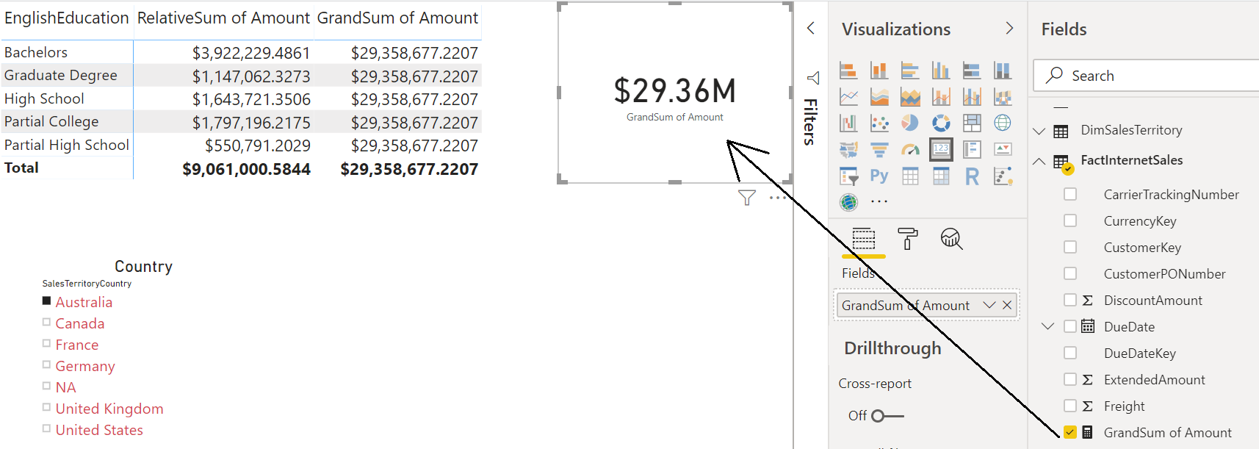

**Other Usage of All function:**

Output of ALL function is a table, so it can be used directly in creating a table or calculated table.

ALL( <table name or column name>, [Column name 1],[column name 2], …)

Example 1: Creating a copy of FactInternetSales table

Sales Copy = All(FactInternetSales)

Example 2: Column Name as the parameter to All function. It will take the distinct values from that column and put those distinct values into column of the new table.

Country List = All(DimSalesTerritory[SalesTerritoryCountry])

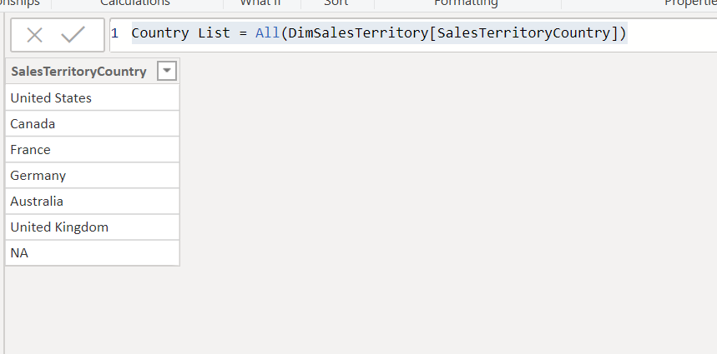

If ALL used with a combination of columns. Such as two columns below, then the combination would be distinct;

MartitalStatus_Gender Combinations = All(DimCustomer[Gender],DimCustomer[MaritalStatus])

